**Chest rub recipe**

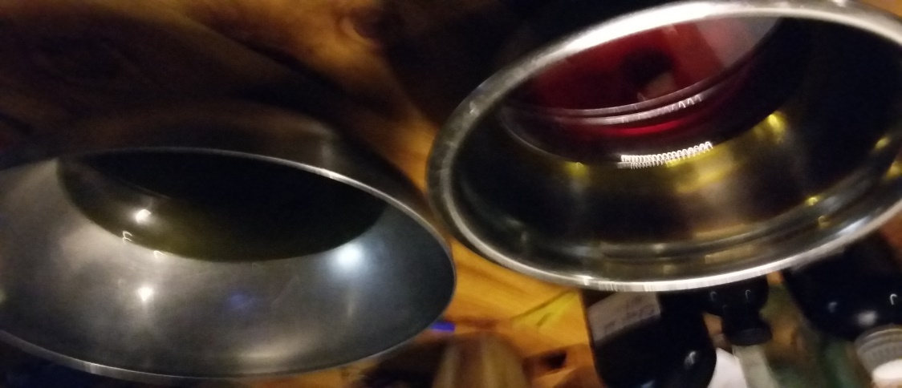

**An absorbable balm is an effective way of taking herbal medicine, especially when the aim is to reach the respiratory system. Chest rubs can be rubbed on the chest , back and soles of the feet – but absorption is especially effective on the perfume points - wrists, neck etc. , where the blood supply is close to the surface.**

This document contains the ingredients for two different recipes, one that would be suitable for infants and children, one suitable for older children and adults**.**

Basic Ingredients

800mls of infused oil

80g of beeswax.

45ml of essential oil for adult chest rub

22 ml of essential for infant chest rub

Basic Method. Adult chest rub

1. Create your recipe
2. Infuse your oils
3. Combine infused oils with beeswax
4. Add essential oils
5. Pour into tubs while still hot.

1. **Create your recipe from the table below**.

The key is the final recipe contains a combination of stimulating (ruberfacient), of expectorant, and anti-microbial herbs. Also a proportion of herbs that contain saponins which will facilitate the absorption of all the different phyto-compounds contained in the infused oils.

|  |  |  |  |
| --- | --- | --- | --- |
| **Stimulating oil** –  Take at least 60 ml and no more than 120 ml  From this column | **Anti-microbial infused oil**  Take at least 300mls and no more than 400mls from this column | **Saponin containing infused oil**  Take at least 300mls and no more than 400mls from this column. | **Essential oils**  must aim to be 5% of the total –  In a mix of 800mls of oil and  100g of wax, , the total e.o.s  total must be 45mls |
| **Chilli –** *capsicum fructens* up to 60ml  **Mustard** *brassica and sinapis species* - up to 120ml  **black pepper** *piper nigrum –* up to 120ml  **Horseradish** *Armoracia rusticana –* up to 120ml | **Bay** laurel *lauris noblis* up to200ml  **Thyme** *- Thymus vulgaris* – up to 200ml  **Elecampane** – *Inula helenium* up to 200ml  **Eucalyptus** *Eucalyptus globulus* up to 200ml | **Ivy** – *Hedera helix* – up to 250ml  **Liquorice** – *Glycyrrhiza glabra* up to 150ml  **Mullein** – *Verbascum Thapsus* up to 250ml  **Lobelia** *lobelia inflata* up to 100ml  **Coltsfoot** *Tussilago farfara* – up to 200ml | Eucalyptus smithii – up to 20mls  Frankincense - - up to 20mls  Thyme linalool - up to 20mls  Eucalyptus globulus – up to 10mls  Benzoin – up to 10mls  Fennel – up to 10mls  Oregano – up to 10mls  Lavender - up to 10mls  Camphor – up to 5mls  Thyme vulgaris - up t0 5mls |

1. **Make your infused oils** .

In a mix of 800mls of infused oil, at least a third (roughly 270mls) of this must be infused in castor oil because it brings its own properties. At least one third ( roughly 270mls )must be almond oil as this is easy to absorb. The other third could be either castor oil, almond oil, a combination of the two – or a different base oil of your choice.

The Proportions of dried herbs to oil may vary with each herb but a guideline might be 15grams of dried herb to every 100mls of oil and thirty grams of fresh to every 100 ml

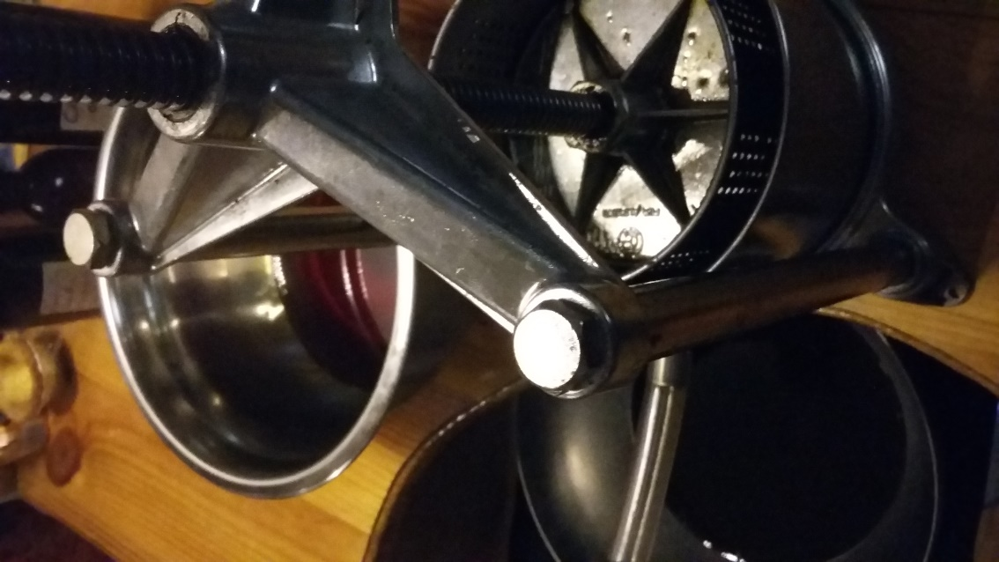

It is not necessary to infuse all the oils separately, but you may choose to do this.

Fresh herbs can make great infused oils, but the water content does reduce shelf life of the oils and can cause the ointment to separate, so for this recipe it is essential that with plants with a high water content such as mullien and coltsfoot, you use the dried plant material. dried plant material. Thyme and ivy leaf may be used fresh.

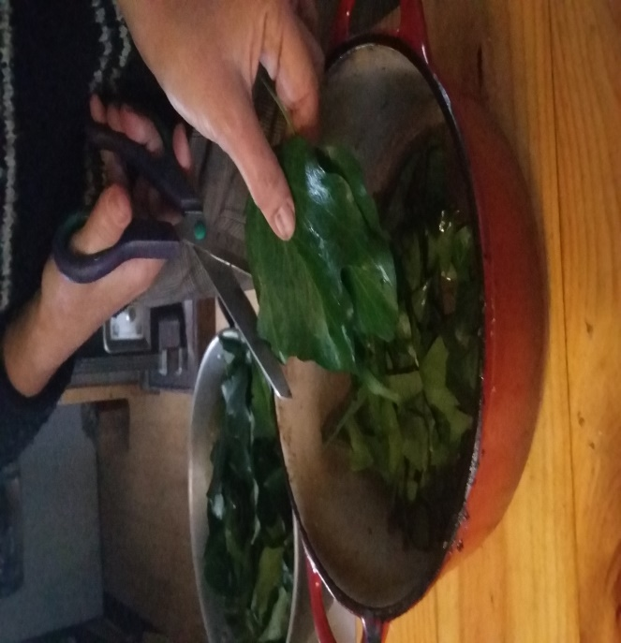

* Clean plant material if necessary but make sure you have removed excess water.
* Chop your plant material very finely.
* Weigh and place into your heating vessel.
* Cover with the oil

You need to find a way to gently heat the oil.

This could be the double boiler or bain marie method where the oil is heated over a simmering water bath

In this method it is necessary to keep the water simmering for 2 hours, taking care not to let the water bath boil dry.

Alternatively you can place in a thick croc pot and leave in a warming oven (such as you might have with a solid fuel stove) over night.

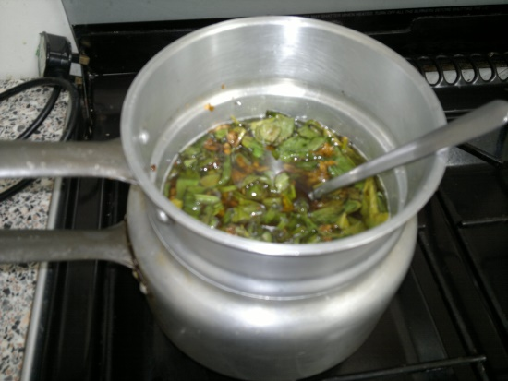

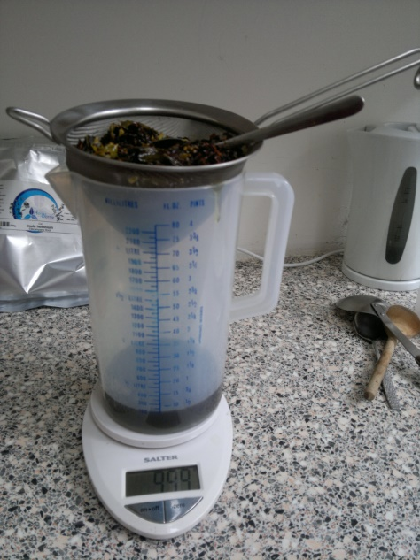Next, strain the oils through a fine sieve

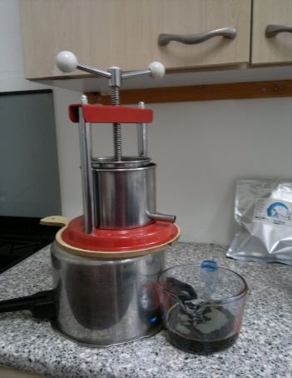

Or use a wine press to get more oil out of the herbs.

Allow the oil to stand for 30 minutes. If a watery sediment settles, pour the clear oil off .

Store in a glass jar away from sunlight ready for the next step.

1. **Combining oil and beeswax**

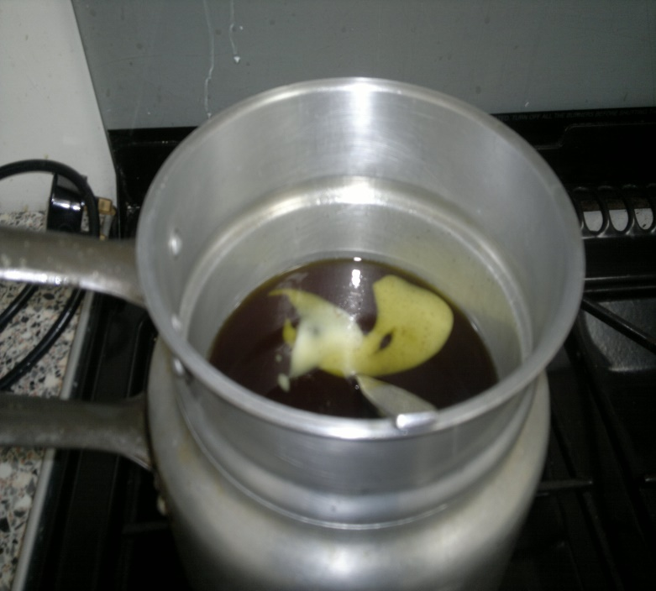 Measure out your combination of infused oils, weigh the beeswax, measure out the essential oils.

Place the oils in clean double boiler or metal jug add beeswax

Heat gently until the wax has melted.

Once all the wax has melted you can test the consistency of the balm by dipping the tip of a chilled teaspoon into the mix.

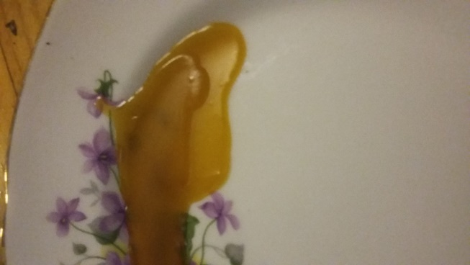

1. **Adding the essential oils .**

Make sure all the tubs are laid out with the lids off ready to receive the hot liquid .

When you are happy that all the wax has thoroughly melted take the hot mixture off the heat and add the essential oils. Stir vigorously .

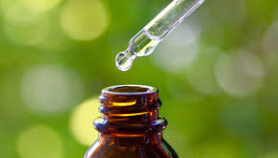

**5. Pour in to tubs .**

This can be tricky and you have to work fast as the ointment can set swiftly.

Leave to cool before you add the lids.

Wipe outsides thoroughly and label.

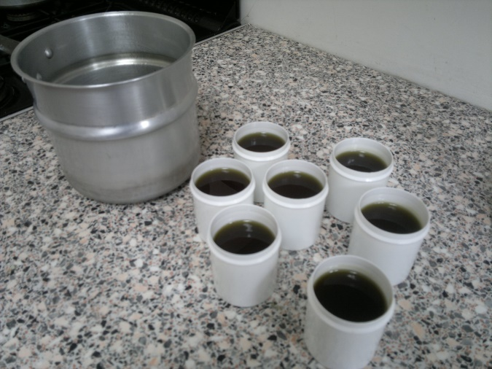

**Infant chest rub.**

Choose your ingredients from the table below and then follow method as for adult chest rub

|  |  |  |
| --- | --- | --- |
| **Anti-microbial infused oil**  Take 400mls from this column – | **Saponin containing infused oil**  Take 400mls from this column. | **Essential oils must aim to be 2.5% of the total** – In a mix of 800mls of oil and 100g of way, total must be 22mls |
| Bay laurel *lauris noblis* up to250ml  Thyme *- Thymus vulgaris* – up to 250ml  Elecampane – *Inula helenium* up to 250ml  Eucalyptus - *Eucalyptus globulus* up to 200ml  Plantain species *- Plantago lanceoata up to 200ml*  Fennel - *foenicular vulgaris* – up to 200ml | Ivy – *Hedera helix* – up to 400ml  Liquorice – *Glycyrrhiza glabra* up to 200 ml  Mullein *– Verbascum Thapsus* up to 400ml | Essential oils each  Thyme linalool - up to 10mls  Eucalyptus smithii – up to 10mls  Frankincense - - up to 10mls  Benzoin – up to 10mls  Fennel – up to 5mls  Oregano – up to 5mls  Lavender 5mls |

